ASSIGNMENT - 3

**Ques 1:- Write a program to calculate the sum of number from m to n** .

Code:

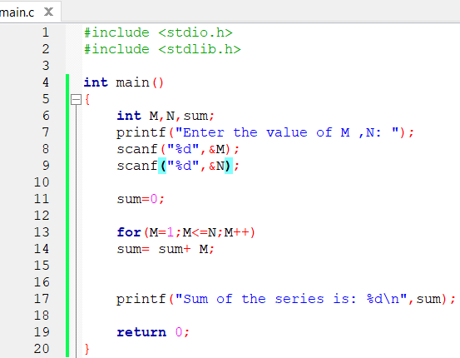

Output:

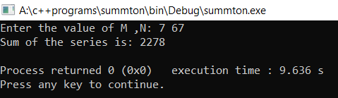

**Ques 2:- Write a program to generate the Fibonacci series up to a given number** .

Code:

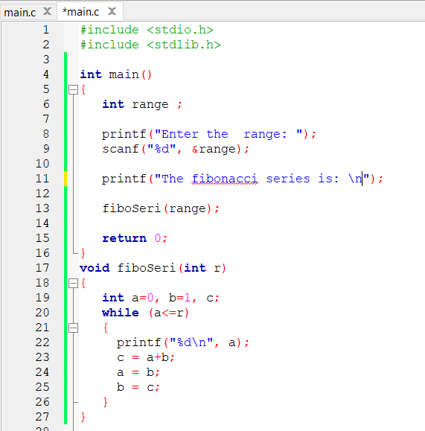

Output:

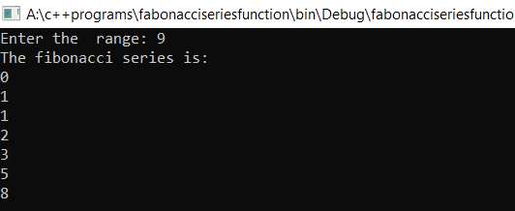

**Ques 3:- WAP to find factorial of a given number recursively****.**

Code:

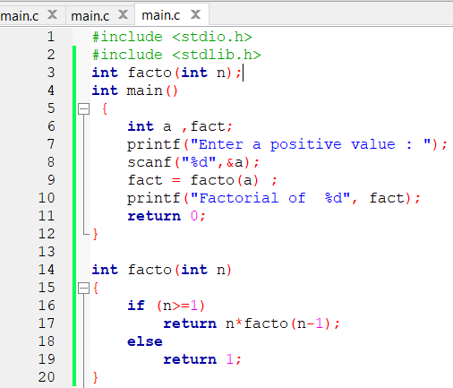

Output:

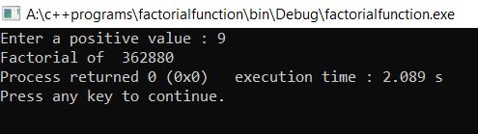

**Ques 4:- WAP to find whether a number is an Armstrong****.**

Code:

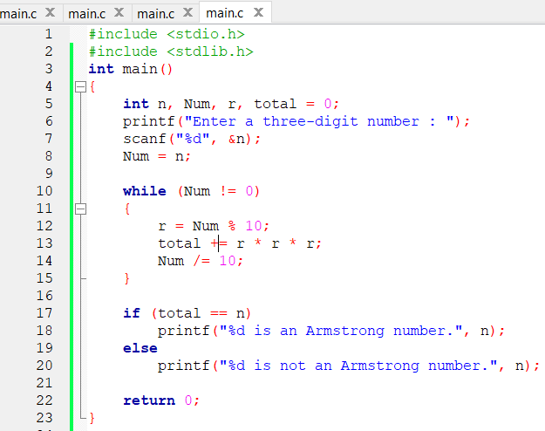

Output:

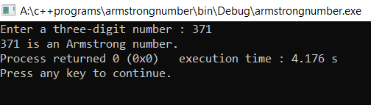

Ques 5:- WAP to check whether number is perfect square or not .

Code:

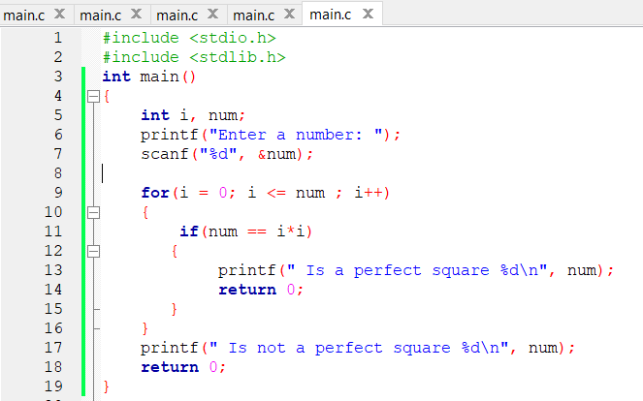

Output:

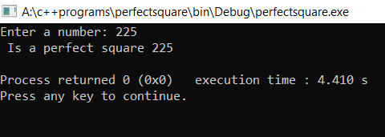

**Ques 6:- WAP to make a menu driven program that perform the function of a calculator using functions and switch case****.**

Code:

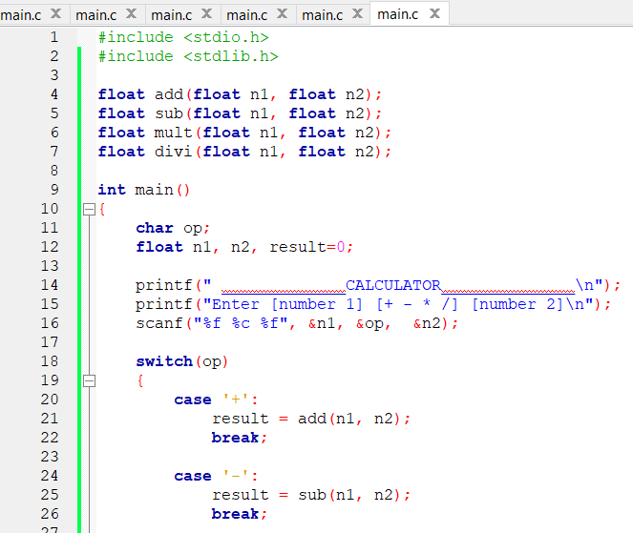

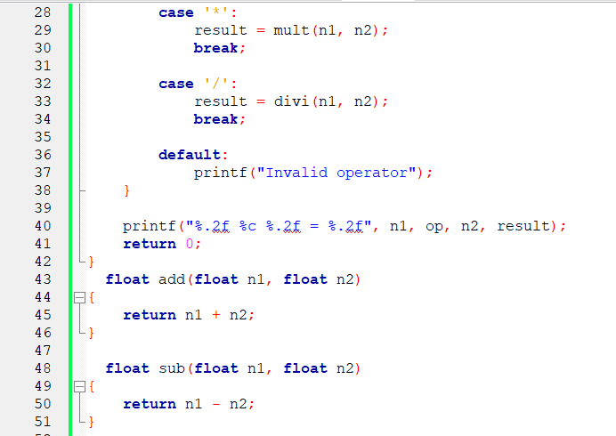

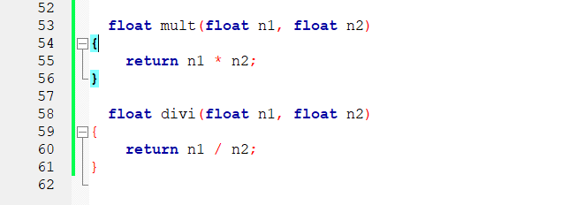

**Ques 7.Write a program to swap the values of two variables using call by reference**

**Ques 09.Write a program to find the biggest of three numbers using functions.**

**Ques 10.Write a function say int sum_of_digits (int number), that returns the sum of digits of an integer number.**

**Ques 11.Write a recursive function say int fact (int n), that returns factorial of a given number.**

**Ques 12.Write a program to check whether a number is Armstrong number or not using functions.**